C Language
____________________________________________________________________________________

Q. What is c language?
_____________________________________________________________________________
C is high level programming language

Q. what is programming?
_____________________________________________________________________
Programming means logical though process which we convert in computer instruction
for perform some atomization work.

How to create application by using c language
__________________________________________________________________________
If we want to create application by using c language we have some following steps.

1) Install turboc++
___________________________________________________________________
Q. what is turboc++?
__________________________________________________________________________________
Turboc++ is editor which provide the environment to us for create and execute c program

You can download the Turboc++ from this link
Download Turbo C++ for Windows 7, 8, 8.1, 10 and Windows 11 (32-64 bit) with full/window screen mode and many more extra features (developerinsider.co)

2) Create Sample Application
__________________________________________________________________________
If we want to create program in c language we have following steps.
a) Add Header in program
____________________________________________________________
Q. what is header file?
__________________________________________________________________
Header file is collection of functions in c language
Q. What is function?
__________________________________________________________________________
Function is the some statements which is used for perform task.
If we want to work with c program we must be add two header file in your code.
stdio.h : standard input and output header file

conio.h: console input and output header file
If we want to add any header file in c program we have to use #include pre processor directives.

Syntax: #include<filename.h>
Example: #include<stdio.h>
#include<conio.h>

b) Write main function and its logic
______________________________________________________________
Main function is heart of c program means without main function we cannot run c program.
So you can write main function like as
Syntax:
void main(){
write here your logics
}
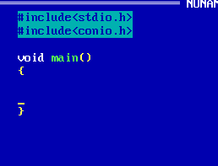
Now we want to create program using c language to display the good morning message
If we want to display anything using c language we have to use printf() function

Syntax: printf(“write here your message”);
Example: printf(“good morning”);

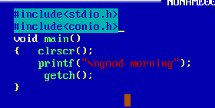
3) Save the application
4) Compile the Application
5) Run application

Data Type in C Language
_________________________________________________________________________
Q. what is data type?
_____________________________________________________________________
Data type means to decide what kind of information or data we want to use in program called as data type.

There are three types of data type in c language
_________________________________________________________________________
1. Built in Data Type or Primitive data type
_______________________________________________________________________
Those data type already present in c language called as built in data type or those data type provided by c language to us called as built in data type.
There are three types of built in data type
a) Integer: Integer data type means those data type store the value without decimal point called as integer data type.
There are four types of Integer Data type
I) Integer:
How to use in program: int

Memory Required: 2 byte
Q. Why 2 byte required for integer?
_____________________________________________________________
Memory size of data type is not fix it is dependent on compiler
Example: TCC compiler required 2 byte memory for integer
GCC compiler required 4 byte memory for integer
JIT compiler required 4 byte memory for integer
Q. Can we see the memory size?
Yes we can see the memory size of data type and for that we have sizeof() operator

Range: Range means decide the calculation capacity of data type or range decide the value storage capacity of data type.

Range: -32768 to 32767

How?

Format specifier: %d

ii) Long Integer:
How to use in program: long int
Memory required: 4 byte
Range: -2147483648 to 2147483647
Format specifier: %ld
iii) Unsigned Integer:
This type of integer helps us to store only positive values.
How to use in program: unsigned int
Memory Required: 2byte
Range: 0 to 65535
Format Specifier: %u

iv) Short integer
How to use in program: short int
Memory Required: 2 byte
Format specifier : %i or %d
Range: -32768 to 32767

b) Float: float data type is used for store the values with decimal point.
There are three types of float data type
1) float
How to use in code: float
Memory Required: 4 byte
Range: 38 38
-3.14 x 10 to 3.14 x 10
Format specifier: %f

2) double:
How to use in code: double
Memory required : 8 byte
Range: 308 308
-1.7 x 10 to 1.7 x 10
Format specifier : %lf
3) long double:
How to use in program: long double
Memory required : 10 byte
Format specifier :%Lf
Range: 4932 4932
-1.7 x 10 to 1.7 x 10

c) Character: Character data type is used for store alpha numeric values.
There are two types of character data type
i) sign char
How to use in program: char
Memory Required: 1 byte
Range:
-128 to 127
Format Specifier: %c

ii) unsign char
How to use in program: unsign char
Memory Required : 1 byte
Range:
0 to 255
Format specifier : %c

2. User defined data type: Those data type define by user for its own use called as user defined data type.
There are three types of user defined data type
a). structure
b). union
c) enum
3. Derived data type: those data type acquire the property another data type called as derived data type.
a) Pointer
b) Function
c) Array

Operators in C Language
__________________________________________________________________
Q. what is operator?
_____________________________________________________________________
Operator are the some symbols to perform some operations

There are seven types of operator in C Langauge
1. Arithmetic: it is used for perform arithmetic operations.
Operator | Meaning
+ | Addition
- | Substraction
* | Multiplication
/ | Division
% | Reminder or modulas
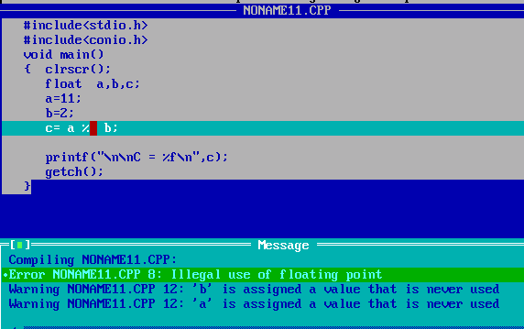
If we think about above code we get compile time error called as illegal use of floating point.

Q. Why?
In The case of c language we cannot use floating value with reminder operator or cannot use
Reminder operator with floating value and use reminder with float in above example so compiler will generate compile time error to us.

How to calculate reminder of floating value
________________________________________________________________________________
If we want to calculate reminder of floating value we have two ways
a) Use fmod() function
fmod() is function from math.h header file which is used for calculate reminder of floating value.
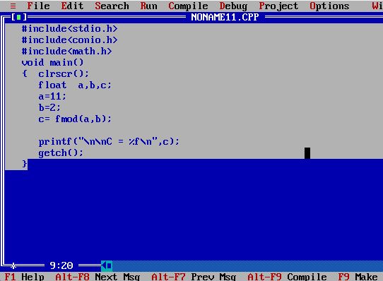

b) Use Type casting technique
Q. what is type casting?
__________________________________________________________________
Type casting means convert one type of data in to another type for single line of code called as type casting.
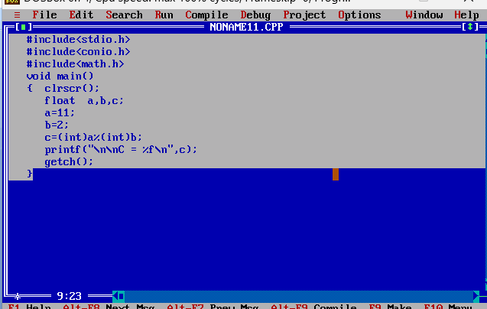
2. Assignment: Assignment operator is used for assign right hand value to left hand variable
Operator | Meaning
= | assignment
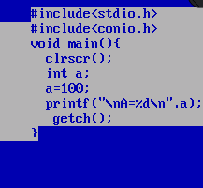

3. Relational: relational operator is used for comparison purpose if comparison gets success return 1 otherwise return 0. In the case of c language 1 means true and 0 means false.
Operator | Meaning
< | Less than
> | Greater than
<= | Less than equal
>= | Greater thane qual
!= | Not equal
== | Equal

4. Logical Operator: Logical operator is used for combine more than one conditions and marks it as single condition and check it.
Operator | Meaning
&& | Logical AND when all your all conditions are true then condition is true otherwise condition is false
|| | Logical OR when all conditions are false then condition false if any one condition is true then condition is true
! | If true then false and if false then true

Note: every logical operator work as logical gate internally

5. Increment or decrement: increment and decrement operator is used for increase the value by 1 and decrease the value by 1
Operator | Meaning
++ | Increase by 1
-- | Decrease by 1
Note: increment operator is short cut of +1 and decrease operator is short of -1
There are two types of increment and decrement operator in c language
a) Pre increment and pre decrement: In the case of pre increment first we perform operation and then we assign value at left hand side.
Syntax: op variablename;
Example: int a=10;
++a; //pre increment
b) Post increment and post decrement: if we think about post increment first we initialize value at left hand side then perform operation
Syntax: variablename op;
Example: int a=10;
a++; //post increment.
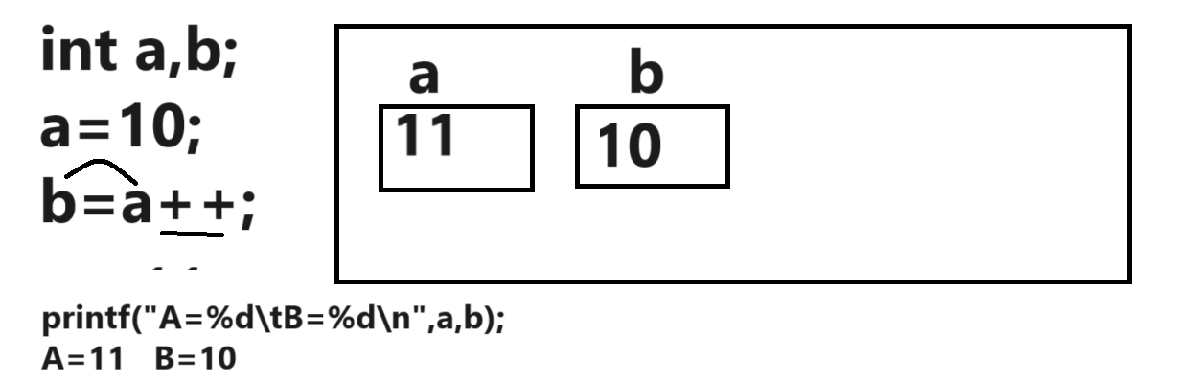

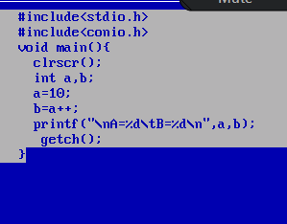
Output:
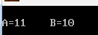

Example of Pre Increment
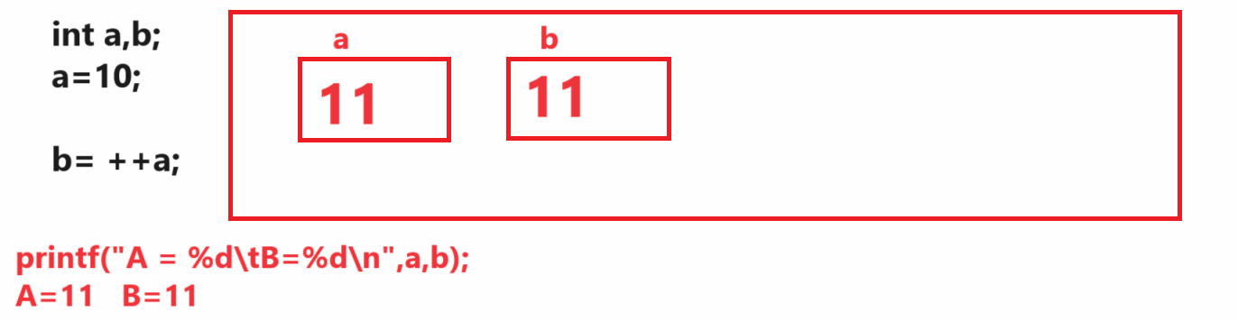
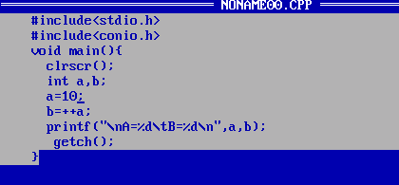
Output:
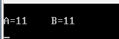
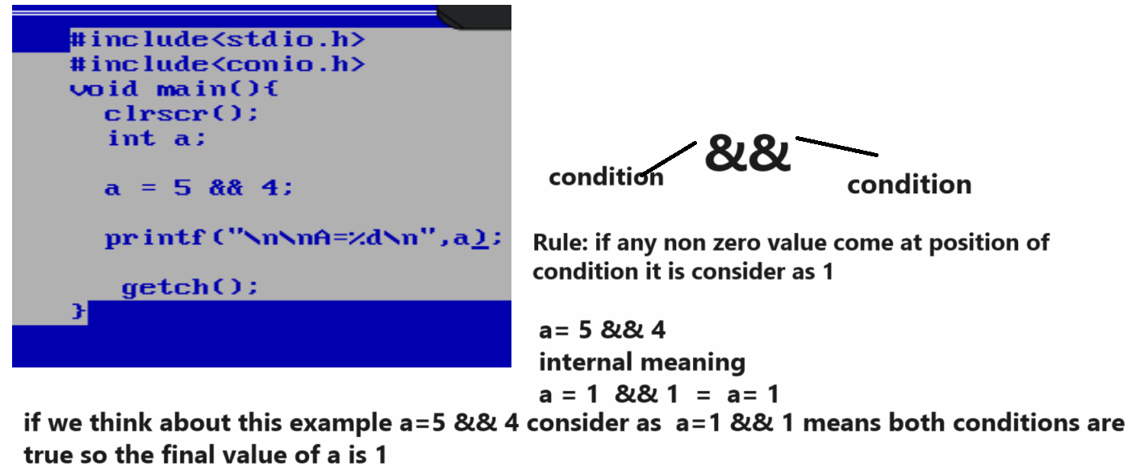
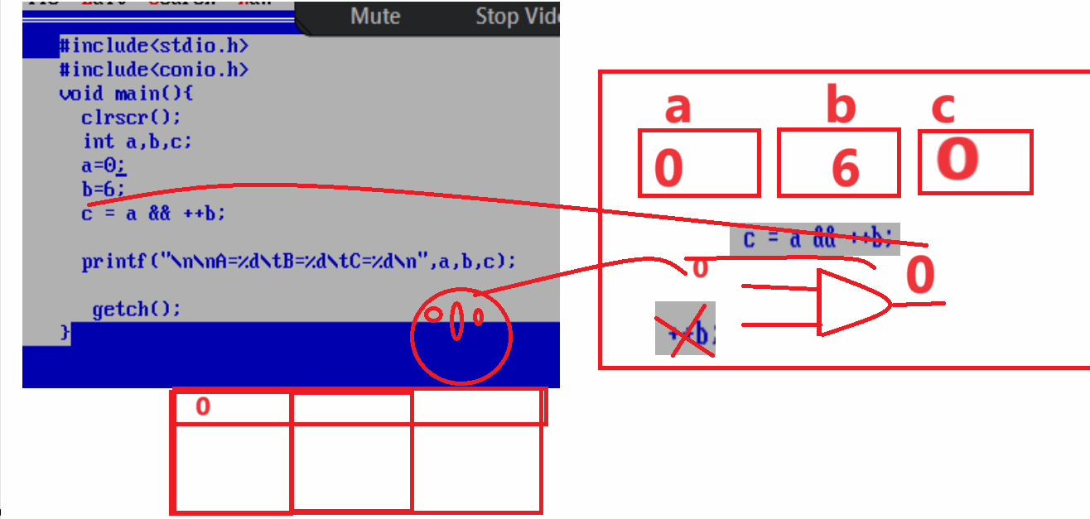
if we think about above code we have statement int a=0,b=6,c; and again we have statement
c= a && ++b; here a is 0 so as per the rule && operator if your first input is 0 then second input not check by c compiler means as per our example ++b is not executed by compiler or not consider by compiler so it is not increment so the value b is remain 6 not 7 and the final output is 0 it is shifted in variable c so the final output is A =0 B=6 C=0

Example of OR Gate
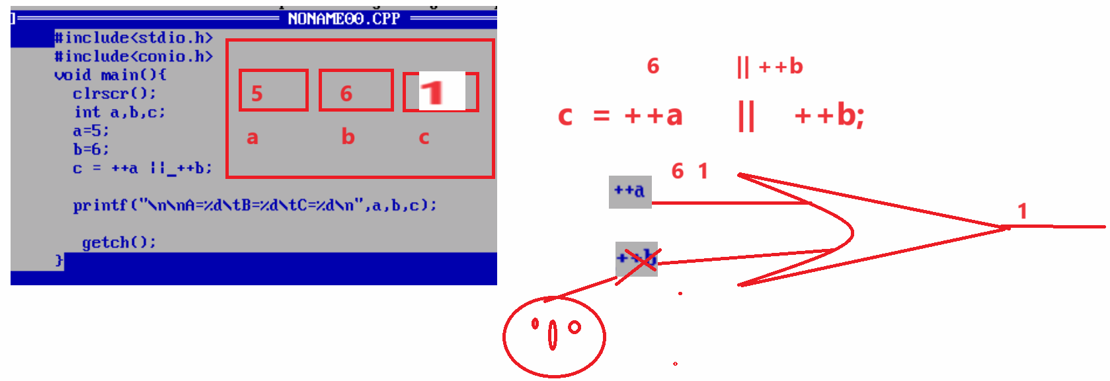

6. Conditional operator: conditional operator is used for check the conditions
Operator | Meaning
? | Ternary operator
: | Colon operator

Syntax: exp1? exp2: exp3;
Here exp1 is always condition and exp2 and exp3 are the options if exp1 is true then exp2 get executed and if exp1 is false then exp3 get executed.
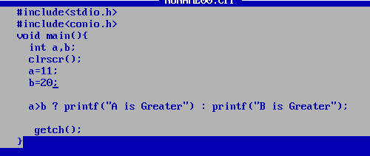

Q. what will be output of given code?
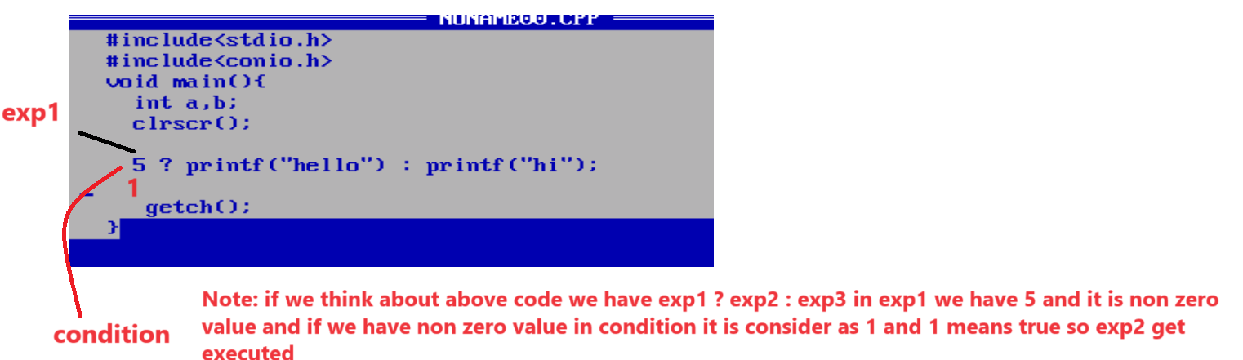

WAP to declare two variables and calculate its addition
_________________________________________________________________________________
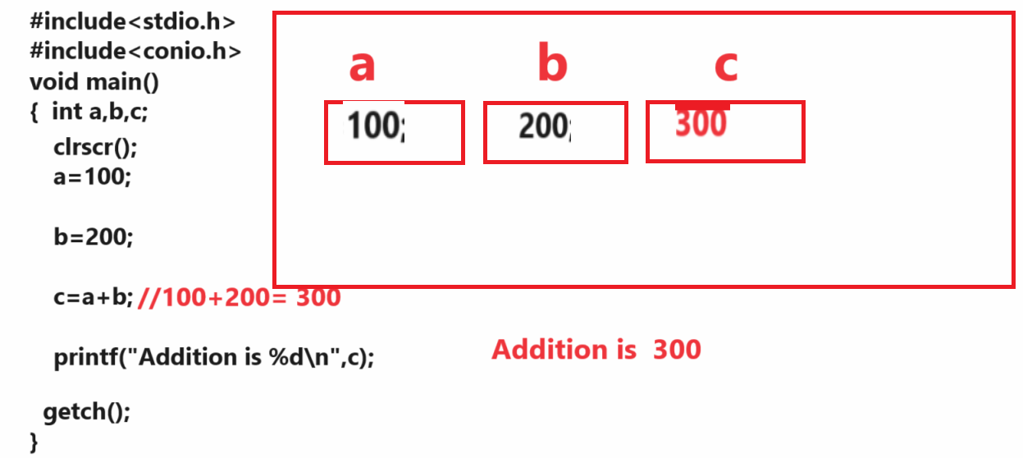
If we think about above code we calculate addition of fix two values we want to accept input from keyboard and after that want to calculate its addition

How to accept input from keyboard
________________________________________________________________________________
If we want to accept input from keyboard we have scanf() function and it is member of stdio.h header file so if we want to use scanf() function we have to add stdio.h header file in your code.

Syntax: scanf(“format specifier” ,&variablename);
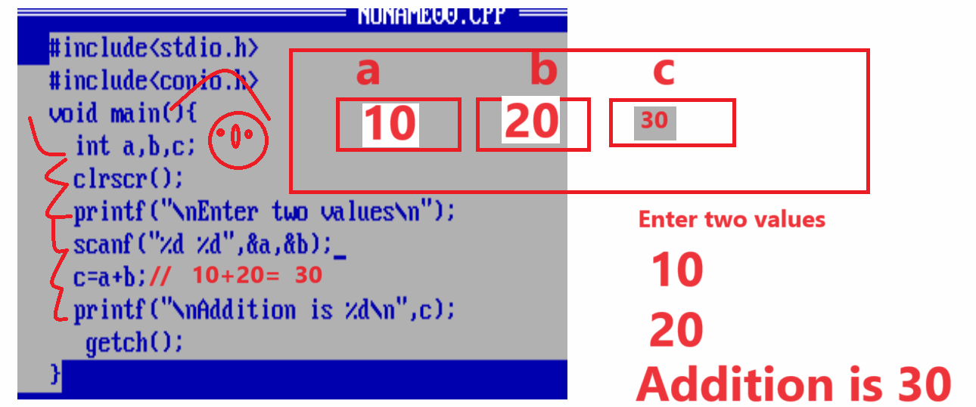
Example: WAP to input the radius of circle and calculate its area
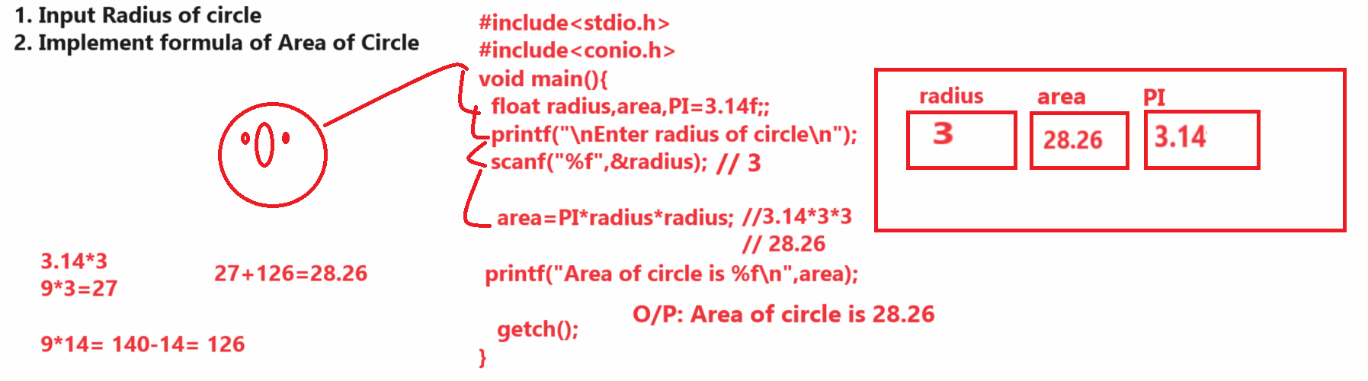

Example: WAP to input the quantity and rate of product and calculate total cost product and apply 18% GST on product and calculate bill with GST
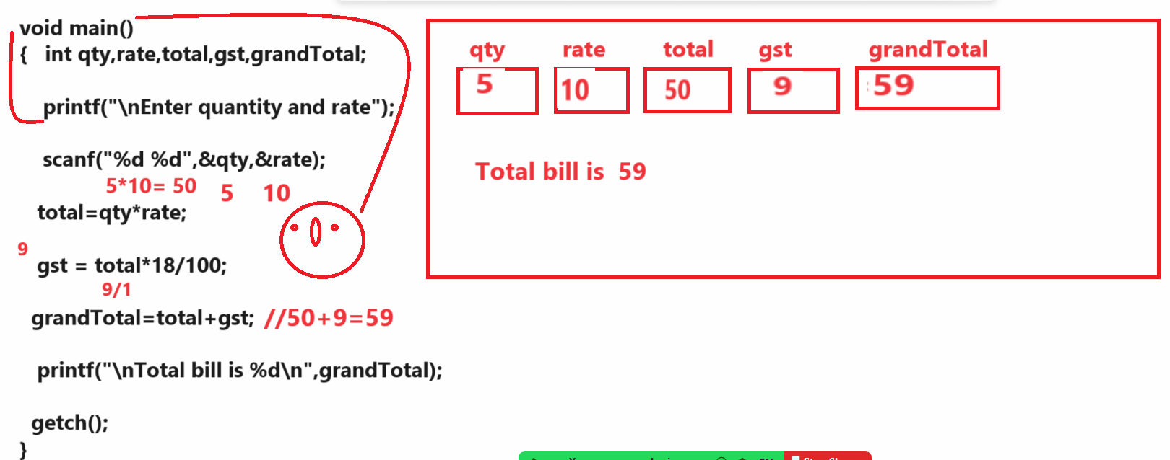

Example: WAP to input the basic salary of employee and calculate its total salary by using following terms
da=30%
hra=30%
bs=1000
da=300
hra=300
total = bs +da + hra; //100+300+300 = 1600
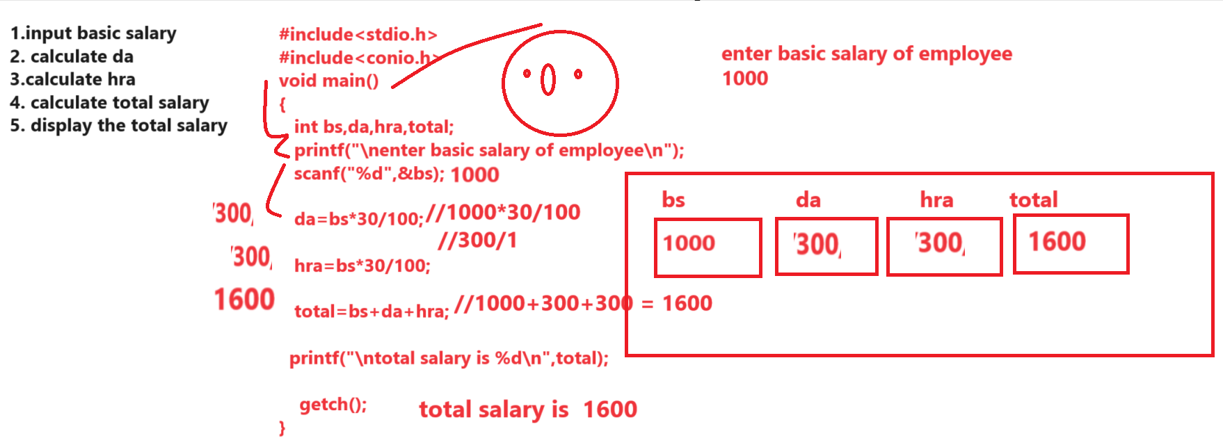

Example: WAP to input the selling price and cost price of item and check seller made profit or loss.
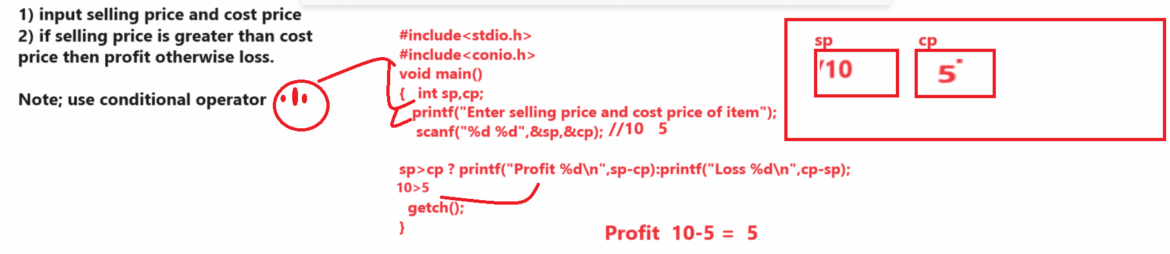
Example:
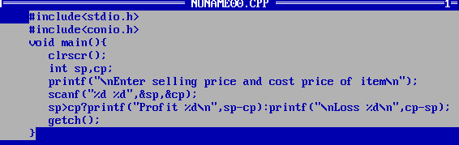

Example: WAP to input the number and extract its last digit
Input: 12345
Output: Last digit is 5
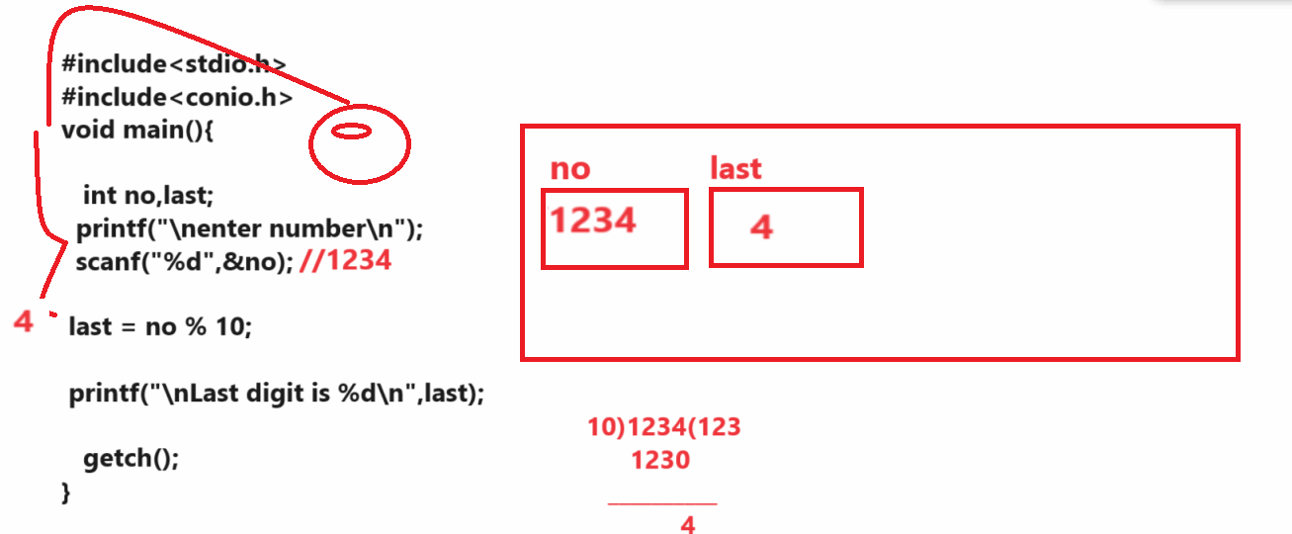

Example: WAP to input the number and remove the last digit from number
Input: 12345
Output: 1234

Note: if we want to remove the last digit from any number you have to divide the number by 10
and store its result in same variable.
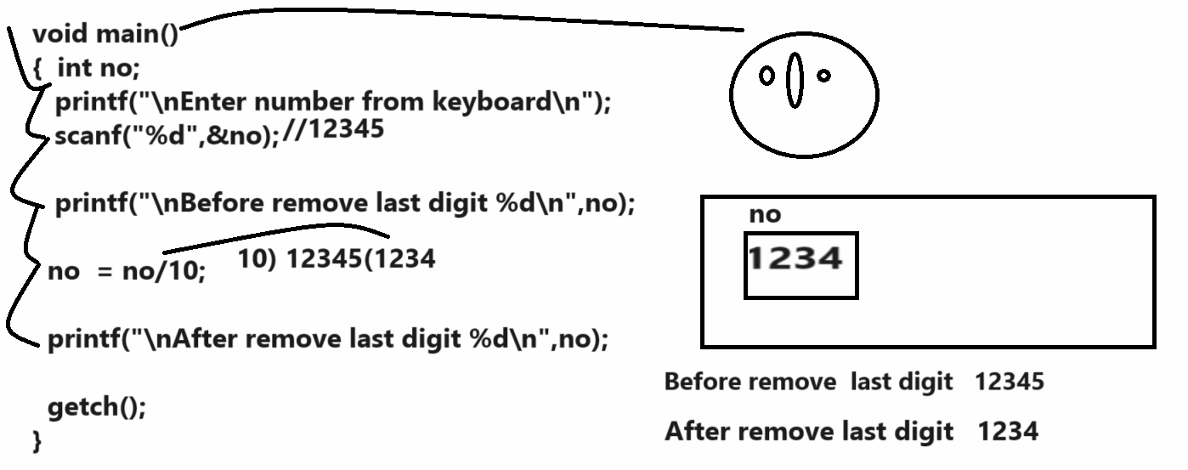
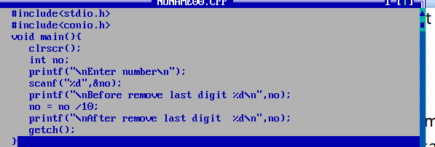

Example: WAP to input 3 digit numbers and calculate sum of its all digit.
Example: 123
Output: 1+2+3 = 6

Example: WAP to input three digit numbers and reverse it.
Input: 123
Output: 321
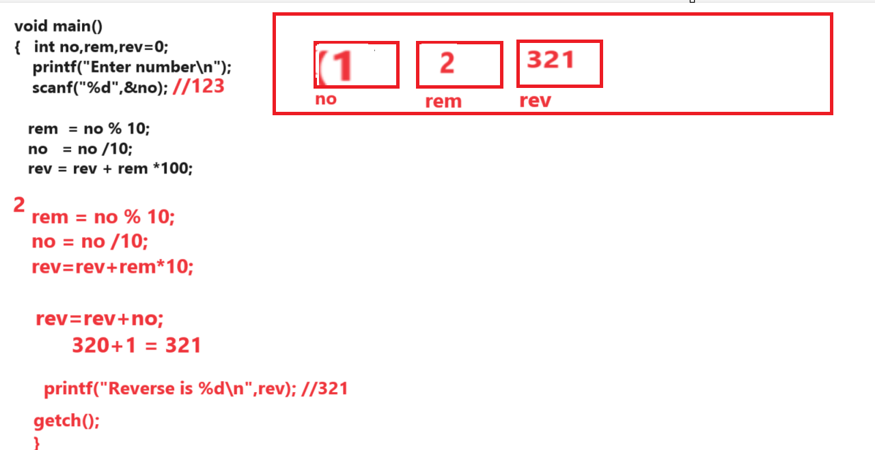
Source code
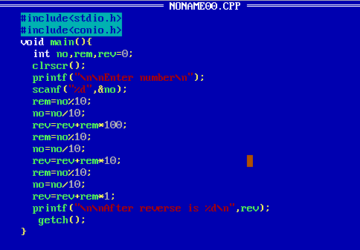
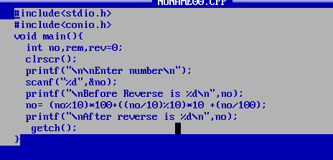

Example: WAP to input the six subject marks of student and calculate its percentage and check student pass or fail if per greater than 35 then declare student is pass otherwise declare student is fail.
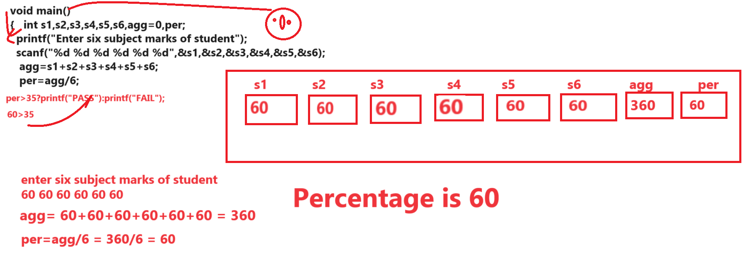
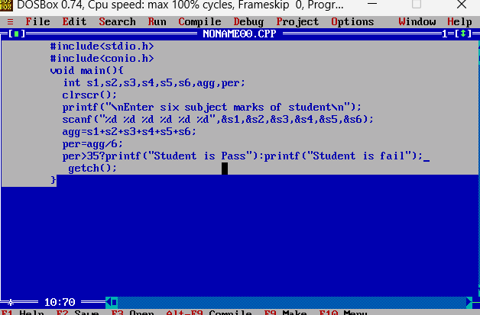

Example: WAP to input four digit number and swap its first and last digit
Input: 1234
Output: 4231
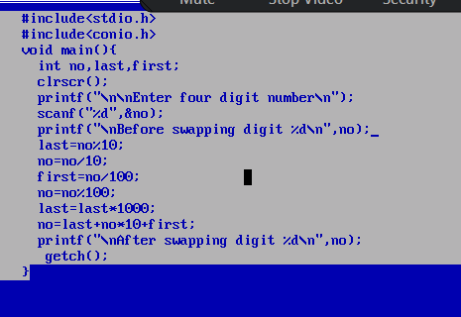
Q. what will be output of given code?
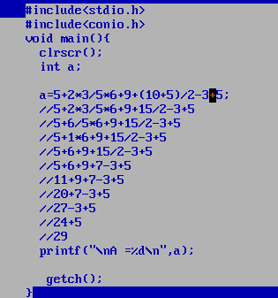

7. Bitwise operator

